भारत मौसम विज्ञान विभाग |  | India Meteorological Department
Friday 01st May 2026 (11th Vaisakha 1948 Saka)
Summary of observations recorded at 0830 hours IST: The Western Disturbance as a cyclonic circulation over Kashmir & neighbourhood persisted and seen at 5.8 km above m. s. l. Another Western Disturbance seen as a trough in middle tropospheric westerlies ran roughly along Long. 55°E to the north of Lat. 30°N. The induced upper air cyclonic circulation over north Punjab & neighbourhood at 1.5 km above m. s. l. persisted. The trough/ wind discontinuity ran from South Odisha to Gulf of Mannar across Telangana, Andhra Pradesh and Tamil Nadu at 0.9 km above m. s. l. persisted and seen upto 1.5 km above m. s. l. The upper air cyclonic circulation over Gangetic West Bengal & adjoining Bangladesh persisted and extended upto 1.5 km above m. s. l. An upper air cyclonic circulation lay over southeast Bangladesh and neighbourhood between 3.1 & 5.8 km above m. s. l. with the trough aloft with its axis at 7.6 km above m. s. l. ran roughly along Long. 89°E to the north of Lat. 20°N. The trough in westerlies between 3.1 & 7.6 km above m. s. l. roughly along Long. 90°E to the north of Lat. 22°N merged with above system. The trough from southeast Uttar Pradesh to north interior Odisha ran from south Punjab adjoining northwest Rajasthan to central parts of Madhya Pradesh across East Rajasthan at 0.9 km above m. s. l. at 0530 hrs IST of today morning. It became less marked. The upper air cyclonic circulation over Southeast Uttar Pradesh & neighbourhood became less marked at 0530 hrs IST of today morning. The upper air cyclonic circulation over northeast Bangladesh & neighbourhood at 0530 hrs IST of today morning.
Maximum Temperature Departures (as on 30-04-2026):markedly below normal ( less than -5.1°C) at a few places over Bihar, Jharkhand; at isolated places over Himachal Pradesh, East Uttar Pradesh, East Madhya Pradesh, Gangetic West Bengal, Nagaland; appreciably below normal (-5.0°C to -3.1°C) at a few places over Mizoram; at isolated places over Sub-Himalayan West Bengal & Sikkim, Assam & Meghalaya, Tripura, Odisha; below normal (-3.0°C to -1.6°C) at isolated places over West Uttar Pradesh; above normal(1.6°C to 3.0°C) at a few places over Tamil Nadu, Puducherry & Karaikal , Kerala & Mahe; at isolated places over Coastal Andhra Pradesh & Yanam, Kerala & Mahe, Vidarbha and Telangana. The highest maximum temperature of 44.6°C was reported at CHANDRAPUR (Chanda) (Maharashtra).
Thunderstorm accompanied with Squally/Gusty winds with speed reaching 50-75 kmph prevailed at isolated places over Bihar, Madhya Maharashtra, Uttarakhand, Gangetic West Bengal, Mizoram, Chhattisgarh, East Rajasthan, Jharkhand, Odisha, Madhya Pradesh, West Uttar Pradesh; with speed reaching 30-50 kmph prevailed at isolated places over Konkan, Marathwada, Arunachal Pradesh, Vidarbha, Assam, East Uttar Pradesh, Gujarat State and Bihar.
Hailstorm reported over Himachal Pradesh, Uttarakhand, Haryana, Uttar Pradesh, Madhya Pradesh, Chhattisgarh, Odisha and Telangana.
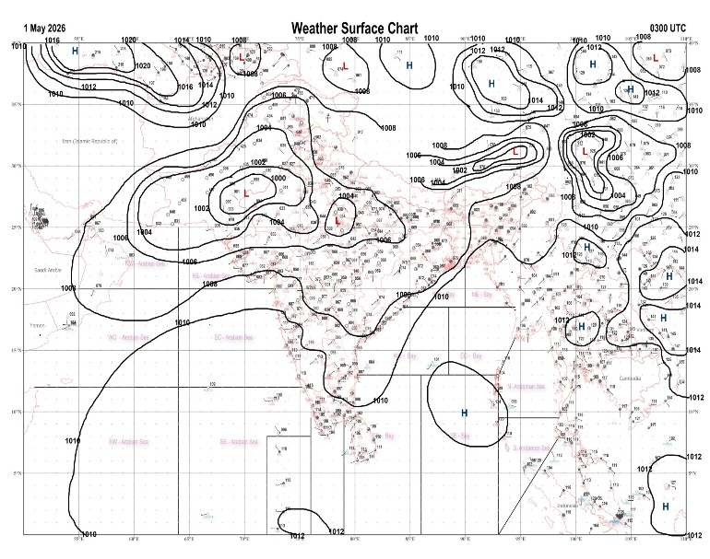 | 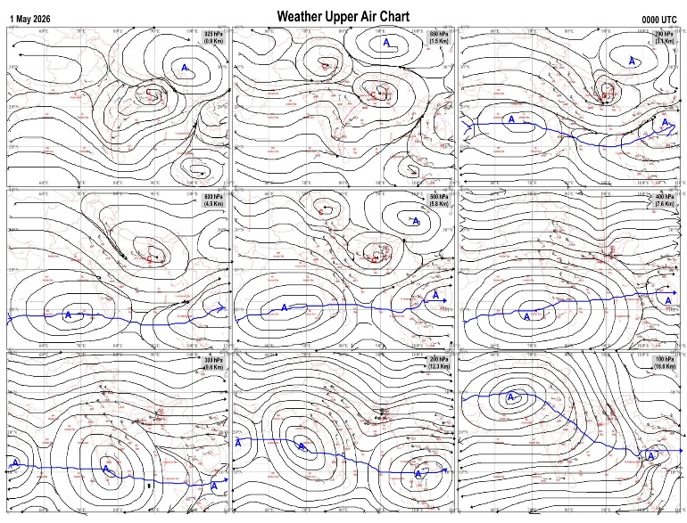
Fig.1. Analysed surface chart based on 03z observation | Fig.2. Analysed upper air chart based on 00z observation
Dr. S.D.Sanap
Scientist ‘D’
CR & S Office, Pune  Issued at 1245 hrs. IST |  | Weather Forecasting Division  CR&S, Pune

Indian regions | Realised rainfall (chief amount in cm during past 24 hrs):
East | most places: Gangetic West Bengal and Odisha+  many places: Arunachal Pradesh  a few places: Assam & Meghalaya+, Sub-Himalayan West Bengal & Sikkim and Jharkhand  isolated places: Nagaland-Manipur-Mizoram-Tripura and Bihar  Banspal 9.1, Betanati 7.5, Puri 6.9, Beky rly.bridge 6.8, Dhemaji 6.1, Rajauli 5.8, Jhargram PTO & Digha 5.2 each, N.lakhimpur / Lilabari & Bagati 5.1 each, Manjhari 4.7, Zrs darisai 4.5, Kashichak 4.3, Mangan 3.8, Deomali AWS 3.7, Singhik 3.6, Jamshedpur 3.4, Zunheboto 3.2, Tawang 2.9, Pasighat AP & Sabroom 1.1 each, Kalimpong 1.0, Jamui 0.5, Kohima 0.2.
North | most places: Uttarakhand  a few places: Uttar Pradesh  isolated places: Haryana, Punjab, Himachal Pradesh, Jammu-Kashmir and Ladakh and east Rajasthan  dry weather: west Rajasthan  Betalghat 6.2, Tirwa 5.4, Balrampur (t) & Mussoorie 5.3 each, Kheri lakhimpur 5.2, Gairsain 3.9, Shimla AP 3.4, Baheri 2.9, Govardhan 2.5, Raj pura ARG 2.2, Nilokheri 2.1, Chabra 1.8, Shahbad & Simla 1.6 each, Chaksu 1.5, Agra 1.4, Poonch & Jaipur AP 1.3 each, Kasauli & Pahalgam 1.1 each, Mohali AWS 0.5, Ambala 0.4, Nawanshahr 0.2.
Central | a few places: east Madhya Pradesh  isolated places: west Madhya Pradesh and Chhattisgarh  dry weather: Vidarbha  Tikamgarh-aws 3.2, Bhitarwar 3.1, Majholi 1.8, Karera & Devendranagar 1.6 each, Mainpur 1.5, Chandrapur 1.0, Datia-aws 0.9, Bilaspur 0.2.
Peninsula | a few places: south interior Karnataka and Kerala++  isolated places: coastal Andhra Pradesh, Telangana, Rayalaseema, Tamil Nadu+, coastal Karnataka◆ and north interior Karnataka◆  dry weather: Gujarat State, Konkan & Goa, Madhya Maharashtra and Marathwada  Palode AWS 11.6, Oothu 7.8, Nalumukku 7.1, Thennala AWS 6.5, Tekkali 6.4, Punalur 4.6, Electronic city ARG 4.3, Kalingapatnam 4.1, Pathapatnam 3.7, Sargur 3.5, Tanakal & Mysuru PTO 3.4 each, Pullampeta 2.5, Anantpur 1.9, Uthagamandalam 1.6, Manuguru 0.8, Dharmasthala 0.2, Aswapuram, Kota & Nargund 0.1 each.
Islands | dry weather: Andaman & Nicobar and Lakshadweep
Table-2 Forecast / warnings (distribution of rain / thundershowers) for 7 days (valid from time of origin upto 0830 hrsIST of next day)
Sr N. |  | Sub-division Name | Day 1 | Day 2 | Day 3 | Day 4 | Day 5 | Day 6 | Day 7 | Sr. No. | Sub-division Name | Day 1 | Day 2 | Day 3 | Day 4 | Day 5 | Day 6 | Day 7
 |  |  | 01 May | 02 May | 03 May | 04 May | 05 May | 06 May | 07 May |  |  | 01 May | 02 May | 03 May | 04 May | 05 May | 06 May | 07 May
 | 1 | Andaman Nicobar Islands | D | D | D | S | I | I | I | 19 | west Madhya Pradesh | I  | I  | I  | I  | I  | I | I
 | 2 | Arunachal Pradesh | W ++ | W + | W +  | F +  | F | F + | W + | 20 | east Madhya Pradesh | I  | I  | I  | I  | I  | I | I
 | 3 | Assam-Meghalaya | W ++  | W ++  | W ++  | F + | F | F | F + | 21 | Gujarat region | D | D | D | D | D | D | D
 | 4 | Nagaland-Manipur-Mizoram-Tripura | W++ | W+ | W+  | F + | F + | S | S | 22 | Saurashtra and Kutch | D | D | D | D | D | D | D
 | 5 | Sub Him West Bengal/Sikkim | W ++  | W++ | W+ | F | F | F | F | 23 | Konkan and Goa | D | D | D | D | D | D | D
 | 6 | Gangetic West Bengal | S  | F  | F  | W  | F | S | S | 24 | Madhya Maharashtra | D | D | D | D | D | D | D
 | 7 | Odisha | S  | S  | S  | S  | S | I | I | 25 | Marathwada | D | D | D | D | D | I | I
 | 8 | Jharkhand | S  | I  | I  | S  | S | S | S | 26 | Vidarbha | D | D | I  | I  | I  | I | D
 | 9 | Bihar | S +  | I  | I  | S  | I | I | I | 27 | Chhattisgarh | I  | I  | I  | I  | I  | I | I
 | 10 | east Uttar Pradesh | I | I | I | S  | S | S | I | 28 | Coastal Andhra Pradesh and Yanam | I + | I + | I + | I  | I  | I | I
 | 11 | west Uttar Pradesh | D | D | I | S  | S | S | I | 29 | Telangana | I  | I  | I  | S  | S  | S | S
 | 12 | Uttarakhand | I | I | F  | F  | F  | S  | S | 30 | Rayalaseema | I  | I | I | I | I | I | I
 | 13 | Haryana,Chandigarh and Delhi | D | I  | I  | S  | S | I | I | 31 | Tamil Nadu, Puducherry and Karaikal | S +  + | S +  + | I +  + | S +  + | I  + | I | I
 | 14 | Punjab | D | I  | I  | S  | S | I | I | 32 | Coastal Karnataka | I  + | I  + | I | I | I | I | I
 | 15 | Himachal Pradesh | I | I | F | F | S | S | I | 33 | North interior Karnataka | I | I  | I | I | S | I | I
 | 16 | Jammu-Kashmir and Ladakh | S | S  | W | F  | F | I | I | 34 | South interior Karnataka | S | I  | I  | I  | S  | I | I
 | 17 | west Rajasthan | I  | I | I  | I  | I | I | I | 35 | Kerala and Mahe | F + | F +  | F+ | F +  | F  | F | F
 | 18 | east Rajasthan | I  | I  | I  | I  | I | I | I | 36 | Lakshadweep | S | S | S | S | S | S | S
Legends: D = Dry I =isolated S = Scattered F = Fairly widespread W = Widespread #= heavy to very heavy rain at a few places with extremely heavy rain at isolated places+++= heavy rain at a few places with very heavy rain at isoIated places++= heavy to very heavy rainfall @=isolated exceptionally heavy rainfall+ = heavy rain ●/*= rain or snow ♦ = very light rain ≡=fog = thunderstorm with lightning =Squall / Gusty / gale / strong wind -=cold wave/cold day + = heat wave/warm night/hot and humid weather =Duststorm =ground frost = Hail.

Fig. 4: Districtwise warnings for five days for Maharashtra State
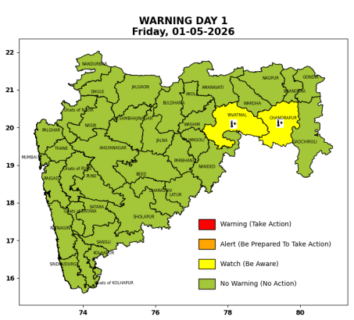 | 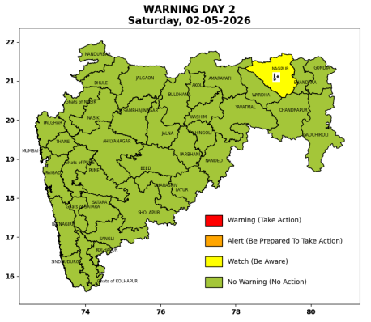 | 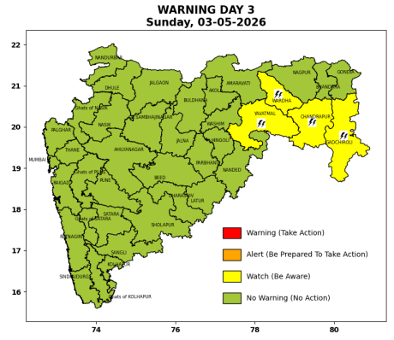 | 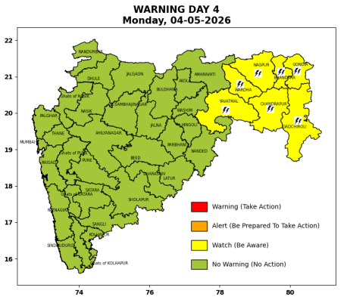 | 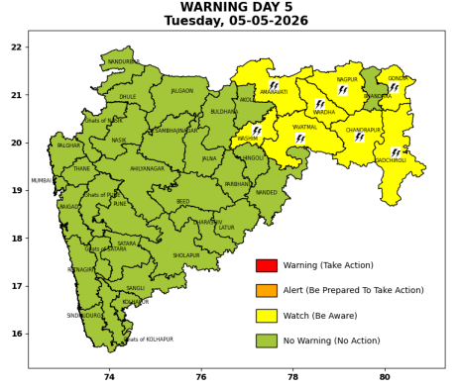

Pune, Lohegaon and Pashan observations at 0830 hrs. IST of Today
 | Temperature (°C) |  |  |  |  | Humidity (%) |  |  |  | Rainfall (mm)
 | Max.  past  24 hrs | Dep.  from  normal | Min.  past  24 hrs. | Dep.  from  normal | Dry  Bulb | At 0830 hrs. IST | Dep.  From  normal | At 1730  hrs. IST of y’day | Dep.  from  normal | Past  24 hrs. | Since  1st March | Dep.  from  normal
PNE | 39.8 | 1.1 | 21.4 | -0.1 | 28.8 | 34 | -12 | 22 | -5 | 0.0 | 92.8 | 79.7
PSN | - | - | - | - | - | - | - | - | - | - | - | -
LHG | - | - | - | - | - | - | - | - | - | - | - | -

 |  |  |  |  |  |  | Local (Pune and neighbourhood) forecast
Max./Min. Temperature (°C) |  |  |  |  |  |  |  |  | Weather
Date | Pune | Pashan | Lohegaon | Chinchwad | Lavale | Magarpatta | NDA | Koregoan park
01/05/26 | 37 / 23.1 | 37 / - | 39 / 23.8* | 36 / 23.2* | - / 19.7* | 39 / 25.2* | 36 / 18.8* | 39 / 24.7* | Mainly clear sky.
02/05/26 | 37 / 22 | 37 / 22 | 39 / 23 | 36 / 22 | 37 / 22 | 39 / 24 | 36 / 18 | 39 / 24 | Mainly clear sky.
03/05/26 | 38 / 22 | 38 / 22 | 40 / 23 | 37 / 22 | 38 / 22 | 40 / 24 | 37 / 18 | 40 / 24 | Mainly clear sky.
04/05/26 | 38 / 21 | 38 / 21 | 40 / 22 | 37 / 21 | 38 / 21 | 40 / 23 | 37 / 17 | 40 / 23 | Mainly clear sky.
05/05/26 | 39 / 21 | 39 / 21 | 41 / 22 | 38 / 21 | 39 / 21 | 41 / 23 | 38 / 17 | 41 / 23 | Mainly clear sky.
06/05/26 | 39 / 22 | 39 / 22 | 41 / 23 | 38 / 22 | 39 / 22 | 41 / 24 | 38 / 18 | 41 / 24 | Mainly clear sky.
07/05/26 | 40 / 22 | 40 / 22 | 41 / 23 | 39 / 22 | 40 / 22 | 41 / 24 | 39 / 18 | 41 / 24 | Mainly clear sky.
* = realized temperatu
Mumbai (Colaba) |  |  |  | Nagpur (AP)
Date 2026 | T max °C | T min °C | Weather | T max °C | T min °C | Weather
01/05/26 | 34 | 26 | Mainly clear sky. | 44 | 25 | Partly cloudy sky.
02/05/26 | 33 | 27 | Mainly clear sky. | 44 | 26 | Partly cloudy sky.
03/05/26 | 32 | 28 | Mainly clear sky. | 43 | 25 | Partly cloudy sky.
04/05/26 | 32 | 27 | Partly cloudy sky towards afternoon or evening. | 43 | 25 | Thunderstorm accompanied with lightning & gusty winds(40-50kmph).
05/05/26 | 33 | 26 | Mainly clear sky. | 42 | 25 | Thunderstorm accompanied with lightning & gusty winds(40-50kmph).
06/05/26 | 34 | 26 | Mainly clear sky. | 43 | 26 | Generally cloudy sky with Light rain.
07/05/26 | 35 | 27 | Partly cloudy sky towards afternoon or evening. | 44 | 28 | Mainly clear sky.
Rainfall Distribution |  |  |  |  | Rainfall Categories | Rainfall (mm) | Cloud condition |  | Rainfall Intensity | Range
Widespread (W) | 76-100% |  |  |  | Very Light rain | Trace to 2.4 mm | Mainly clear sky | 1-2 oktas | Light Spell | 1 cm/hr
 |  |  |  |  | Light rain | 2.5 to 15.5 mm | Partly cloudy sky | 3-4 oktas | Moderate Spell | 1-2 cm/hr
Fairly Widespread (FW) | 51 – 75% |  |  |  | Moderate rain | 15.6 to 64.4 mm | Generally cloudy sky | 5-7 oktas | Intense Spell | 2-3 cm/hr
Scattered (S) | 26 – 50% |  |  |  | Heavy rain | 64.5 to 115.5 mm | Overcast | 8 oktas | Very Intense Spell | 3-5 cm/hr
Isolated (I) | 1 – 25% |  |  |  | Very heavy rain | 115.6 to 204.4 mm |  |  | Extremely Intense Spell | 5-10 cm/hr
Dry (D) | No Rain |  |  |  | Extremely heavy rain | ≥ 204.5 mm |  |  | Cloudburst | > 10 cm/hr
Probability Terms in %: |  |  |  |  | Heavy snow | 6.5 to 11.5 cms water equivalent of rain
unlikely | < 25 |  |  |  | Very heavy snow | 11.6 to 20.4 cms water equivalent of rain
likely | between 25 50
very likely | between 51 75
most likely | >75

